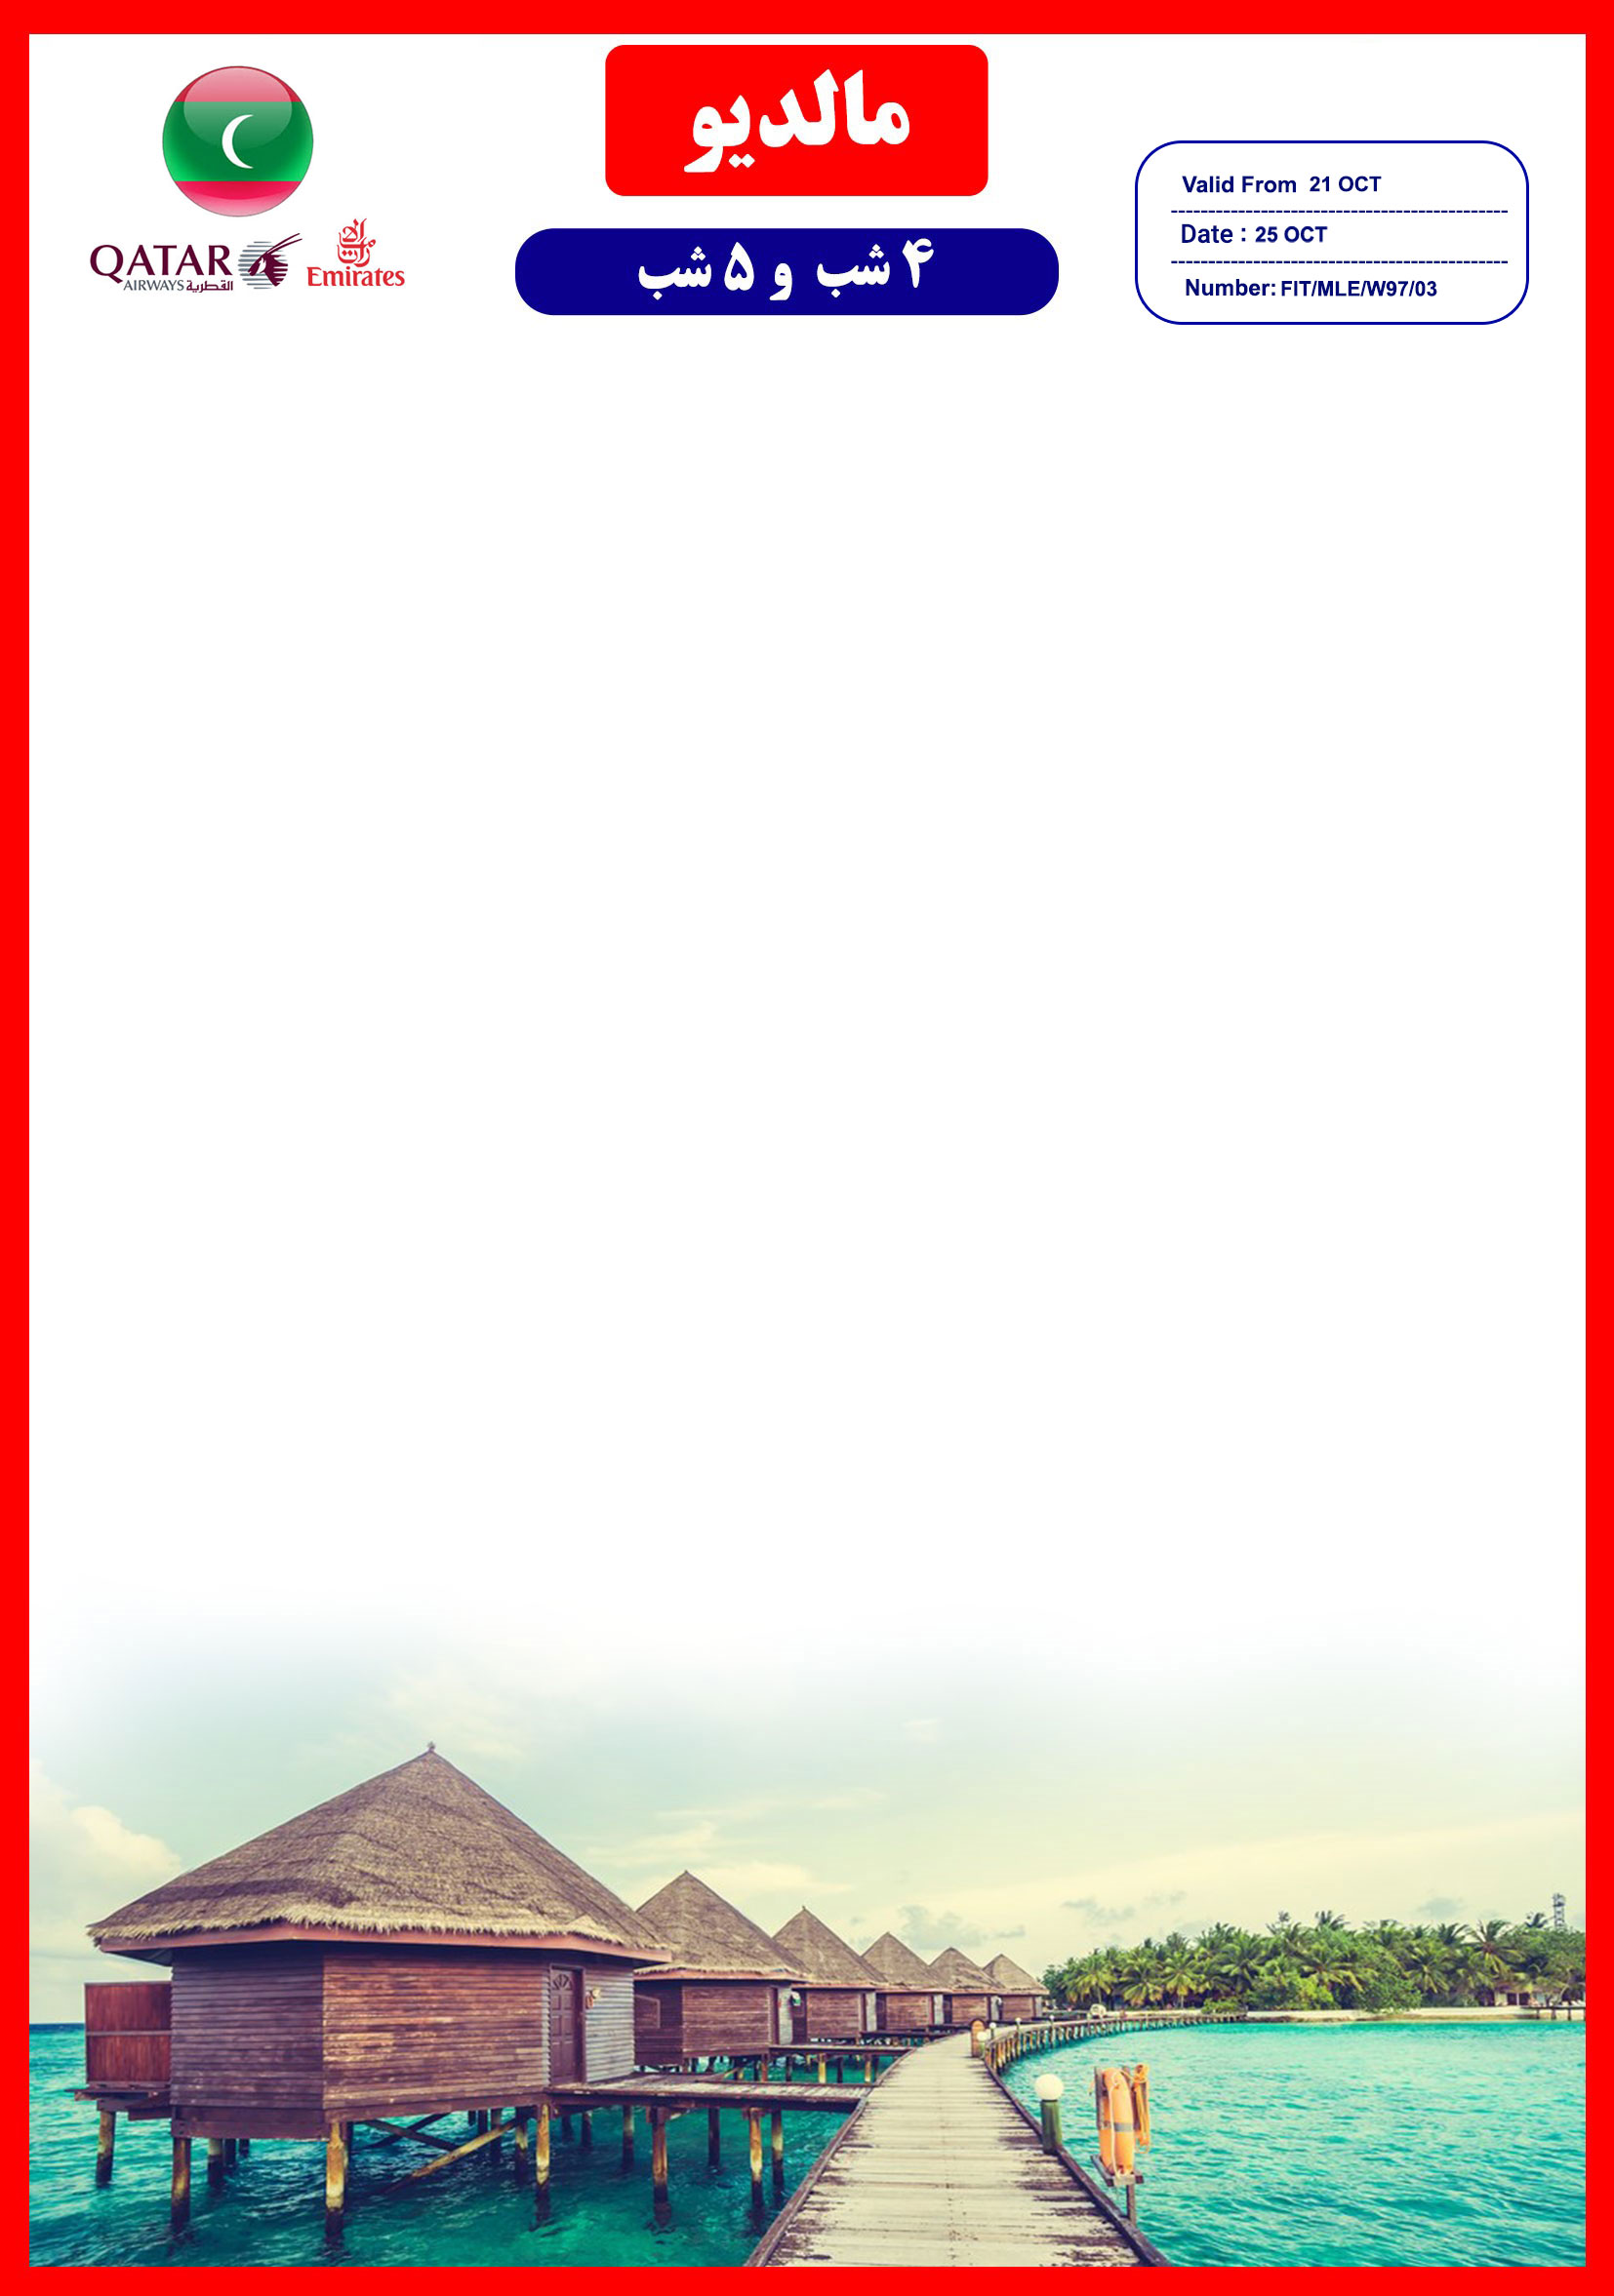
جایگاه لوگو شما

هتل | درجه | نوع اتاق | سرویس | تعداد  شب | SGL | DBL | EXT | CHD | INF
Dhigali Resort  Maldives | 5* | Beach Bungalow | HB | 4 شب | 1.752 | 1.240 | - | - | -
 |  |  |  | 5 شب | 2.190 | 1.550 | - | - | -
 |  | Water Villa | HB | 4 شب | 2.172 | 1.452 | 956 | 712 | 175
 |  |  |  | 5 شب | 2.715 | 1.815 | 1.195 | 890 | 220
 |  | Deluxe Beach Bungalow | HB | 4 شب | 1.968 | 1.348 | 964 | 712 | 175
 |  |  |  | 5 شب | 2.460 | 1.685 | 1.205 | 890 | 220
 |  | Beach Villa | HB | 4 شب | 2.400 | 1.556 | 972 | 712 | 175
 |  |  |  | 5 شب | 3.000 | 1.945 | 1.215 | 890 | 220
 |  | Beach Villa With Pool | HB | 4 شب | 3.280 | 1.972 | 964 | 712 | 175
 |  |  |  | 5 شب | 4.100 | 2.465 | 1.205 | 890 | 220
 |  | Lagoon Villa With Pool | HB | 4 شب | 3.940 | 2.328 | - | - | -
 |  |  |  | 5 شب | 4.925 | 2.910 | - | - | -

پرواز امارات، شروع نرخ از9.870.000 تومان می باشد و هزینه آن به مبالغ فوق اضافه می گردد
مبالغ فوق برحسب دلار می باشد

در صورت درخواست سرویس FB به ازای هر شب، هر نفر 150 دلار به مبالغ فوق اضافه خواهد شد

خدمات تور
- سرویس HB شامل صبحانه و شام می باشد
- ترانسفر اختصاصی با هواپیمای دریایی
- راهنما جهت ترانسفر رفت و برگشت

آفر ویژه پکیج
با ارائه سند ازدواج، درصورتی که بیش از شش ماه، از تاریخ آن نگذشته باشد، یک وعده شام(Candlelit Dinner) مهمان
دلتابان خواهید بود.

نکات مهم :
-مسئولیت کنترل گذرنامه از جهت اعتبار و ممنوعیت خروج از کشور، به عهده مسافر و یا آژانس همکار است.
-مسافرین ملزم به اجرای دقیق برنامه سفر انتخابی هستند و به هیچ وجه تغییری در تاریخ، محل اقامت و..... امکان پذیر نیست.
-مسئولیت کنترل گذرنامه از هر لحاظ ( حداقل 7 ماه اعتبار از تاریخ پرواز) و ممنوعیت خروج از کشور مسافر به عهده آژانس درخواست کننده و خود شخص مسافر می باشد
- هزینه عوارض خروج از کشور به عهده مسافر می باشد
درصورتی که مسافران تمایل داشته باشند از گشت های دیگری بهره مند شوند، می توانند درخواست خود را به دلتابان ارائه نمایند
با توجه به اینکه هتل گارانتی است، امکان کنسل و یا تغییر تاریخ تور میسر نیست.

